“Innovation to Entrepreneurship”
10th August 2023
At
Class Room, Department of Chemistry,
Saurashtra University, Rajkot

Contents
Saurashtra University – IIC 3
Event Schedule 3
Event Registration Link 3
Brief about Event 4
Key Points 5
Outcome 5
About the Speaker/Chief Guest 5
Connect Us: 7

Saurashtra University – IIC
The university is dedicated to instruction, research, and extending knowledge to the public (public service). Ministry of Education (MoE), Govt. of India has established ‘MoE’s Innovation Cell (MIC)’ to systematically foster the culture of Innovation among all Higher Education Institutions (HEIs). The primary mandate of MIC is to encourage, inspire and nurture young students by supporting them to work with new ideas and transform them into prototypes while they are informative years. Saurashtra University is one the Organization that have constituted the IIC to foster the vision of MoE and be a part for the promotion and development of innovation ecosystem.

Event Schedule

Event Registration Link

bit.ly/SUSEC-INEN

Brief about Event
Saurashtra University and IIC have celebrated Innovation to Entrepreneurship on 10th August 2023 with the theme of " inspire and educate aspiring entrepreneurs" on 12:00 pm to 1:30 pm. Innovation plays a central role in entrepreneurship as it involves the replacement or improvement of existing offerings, enabling entrepreneurs.
This event began with the lighting of a lamp. Dr. Girish Bhimani, Honourable Vice Chancellor, Saurashtra University and Dr. Ranjan Khunt, coordinator, SUSEC welcomed the guests in the event. Then the speaker was greeted with a token of appreciation from the chief guest. Dr. Ranjan Khunt gave a brief overview about IIC, SSIP and Incubation Centre. They encouraged students.
Mr. Jayson Ganatra provided valuable insights into the world of entrepreneurship and innovation. Sir emphasized the importance of understanding how to initiate a business venture. These likely involved aspects such as creating a business plan, defining your target audience, and identifying their needs. Knowing your customers' needs is crucial for the success of your business. Furthermore, sir talked about difference between Innovation, Invention & discovery with very good examples.
- Invention: Invention refers to the process of creating something entirely new and unique, often originating from an individual's creative ideas and insights. This could involve developing a new product, technology, or concept that didn't exist before.
- Discovery: Discovery involves identifying something that already exists but hasn't been widely recognized or understood. It's about bringing to light something that was previously hidden or unnoticed. This could pertain to a new scientific phenomenon, a natural resource, or an existing concept that hasn't been explored in depth.
- Innovation: Innovation, on the other hand, involves introducing new and non-obvious methods, products, processes, improvements, or approaches to address a specific problem or need. It often builds upon existing ideas or technologies and focuses on making meaningful changes or advancements to create value.
The speaker played a game called “Ice-Cream Monkey”. Divided work to all participants in groups of 10 and given 10 minutes to identify the problem and how to start their own business. Students participated enthusiastically and this was an interesting game. The objective of this event was to impart practical knowledge to the students.

Key Points

During the session, below mentioned points were discussed:
- Entrepreneurship, and entrepreneurial innovation
- Discovery, invention & innovation
- Market validation
- Find customers’ needs
- FAQs related to Innovation to Entrepreneurship

Outcome

As per the event, students learned that entrepreneurship and innovation are two very closely related phenomena in the sense that innovation requires some form of entrepreneurial behaviour. Also, students understood that not all discoveries, innovation and invention can be startups.
Also, being an entrepreneur requires taking on significant responsibility and comes with significant challenges and potential rewards. Entrepreneurship is a mind-set, an attitude, it is taking a particular approach to doing things was made understood by the speaker with examples.

About the Speaker/Chief Guest

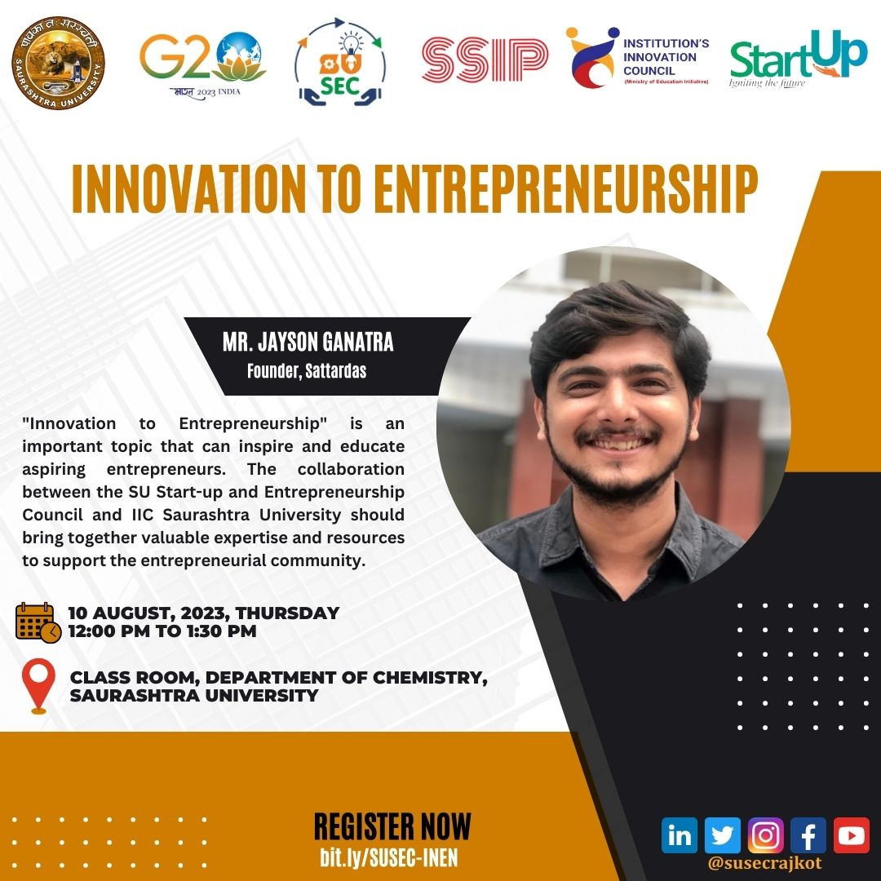

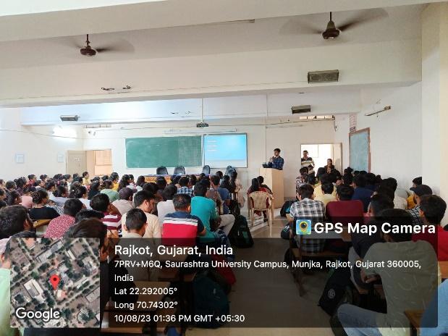
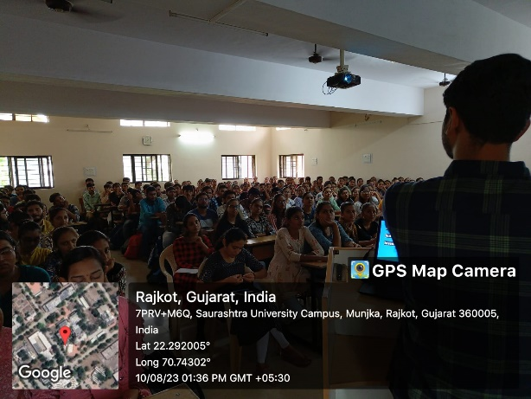
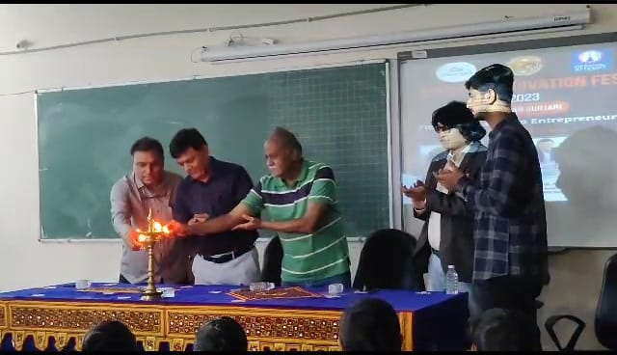
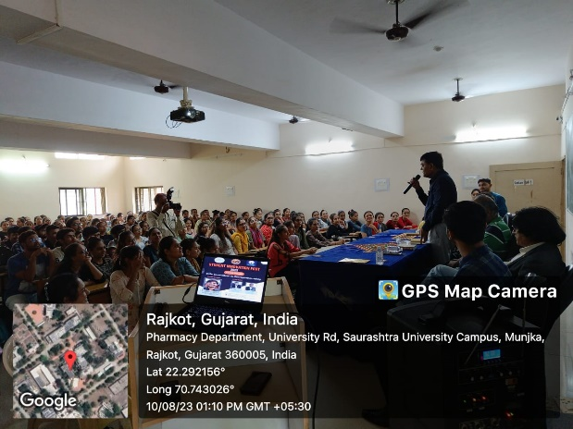
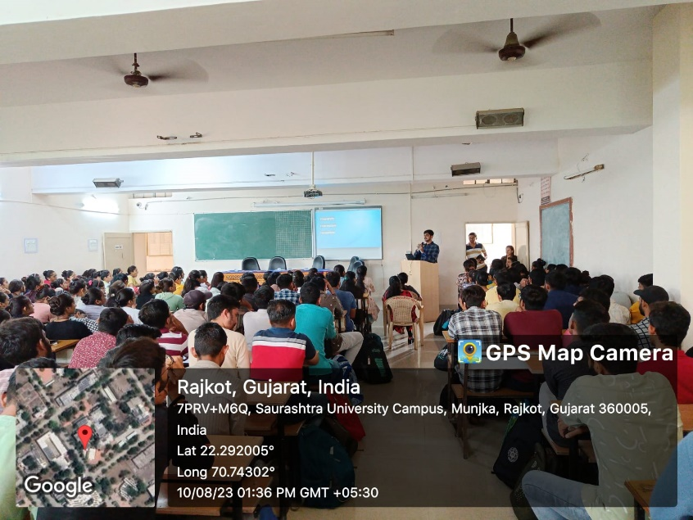

Connect Us:

https://www.linkedin.com/company/susec iic@sauuni.ac.in
https://www.facebook.com/iicsauuni https://bit.ly/SUSECLocation
https://www.instagram.com/susecrajkot https://bit.ly/SUSEC-youtube

